Measuring KINETIC ENERGY
TASK: Measure the Kinetic Energy of a moving object. The kinetic energy of an object is calculated by KE = ½ x mass x velocity².
A very simple science report has been already started for you – see below. You need to complete the report. While this task is simple, the skills you develop will be useful in later experiments. The parts you need to do are…
- make up a suitable method (see the results table for clues)
- Collect results neatly and calculate Kinetic energy
- Graph the dependant variables against the independent variable.
Aim: To measure how mass and velocity affects the kinetic energy of a moving object.
Variables: Independent (2) = mass of the object
Dependant = Kinetic Energy of the object
Controlled = _______________________________________________
Hypothesis: The faster the object, and the more mass it has, the greater the Kinetic Energy it will have. This is because Kinetic Energy is the product of an objects mass and velocity.
Method:
MATERIALS

- Large marble
- Tennis ball
- Baseball or Basketball
- Stopwatch
- Metre ruler
- Electronic balance

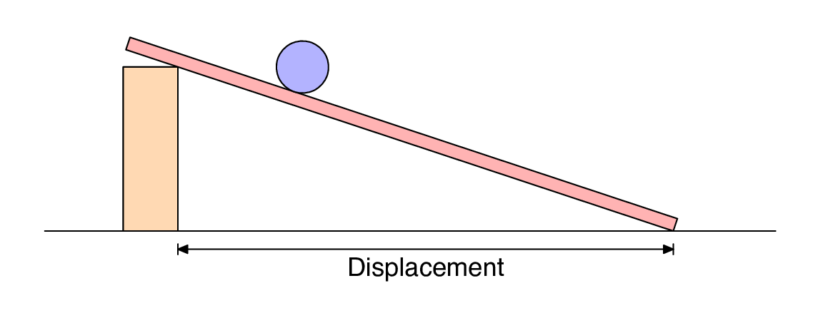


2 m
METHOD:
- __________________________________________________________________
- __________________________________________________________________
- __________________________________________________________________
- __________________________________________________________________
- __________________________________________________________________
- __________________________________________________________________
- __________________________________________________________________
Results:
Table1: mass, velocity and Kinetic Energy of a rolling object.
Object | Mass (in kg) | Distance rolled(m) | Time (seconds) |  |  |  | Velocity (m/s)  Dist / time | Kinetic Energy (J)  ½ x mass x velocity²
Object | Mass (in kg) | Distance rolled(m) | Trial 1 | Trial 2 | Trial 3 | Average | Velocity (m/s)  Dist / time | Kinetic Energy (J)  ½ x mass x velocity²
 |  | 2
 |  | 2
 |  | 2
 |  | 2

Graph1: Kinetic Energy of a rolling object versus the mass
.

Kinetic Energy (J)
Mass (kg)
Questions
1. Describe the trend in the data shown in the graph or table above.

